# Synchronized Web Service Call

1. Background
2. Process Flow

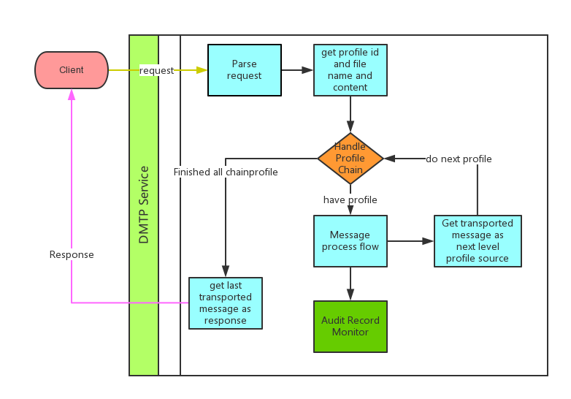

1. Data structure

Profile(mark: isSyncProfile

nextProfile:

OutboundChannel add attri to save transported message

Add profile to ExecutorContext